**Introduction**

**Over View:**

A vehicle that can be fueled by an electric engine that draws power from a battery and is fit for being charged from an outer source and have an electric engine rather than a gas-powered motor.

**Purpose:**

Although the electric vehicle (EV) is not new, it has received much more attention in recent years. Automotive market share has increased as a result of technological advancements in EV analytics and battery technologies. However, hardware alone is not solely to blame for this expansion. A comprehensive transportation solution is created by combining electrical storage and propulsion systems, electronic sensors, controls, and actuators, software, secure data transfer, and data analysis in the modern mechatronic vehicle. All of these advancements analytics is the common thread that connects them all.

Using this project People Can get the knowledge about EV. You can change ignorance about Electric Vehicle.

**Empathy Map:**

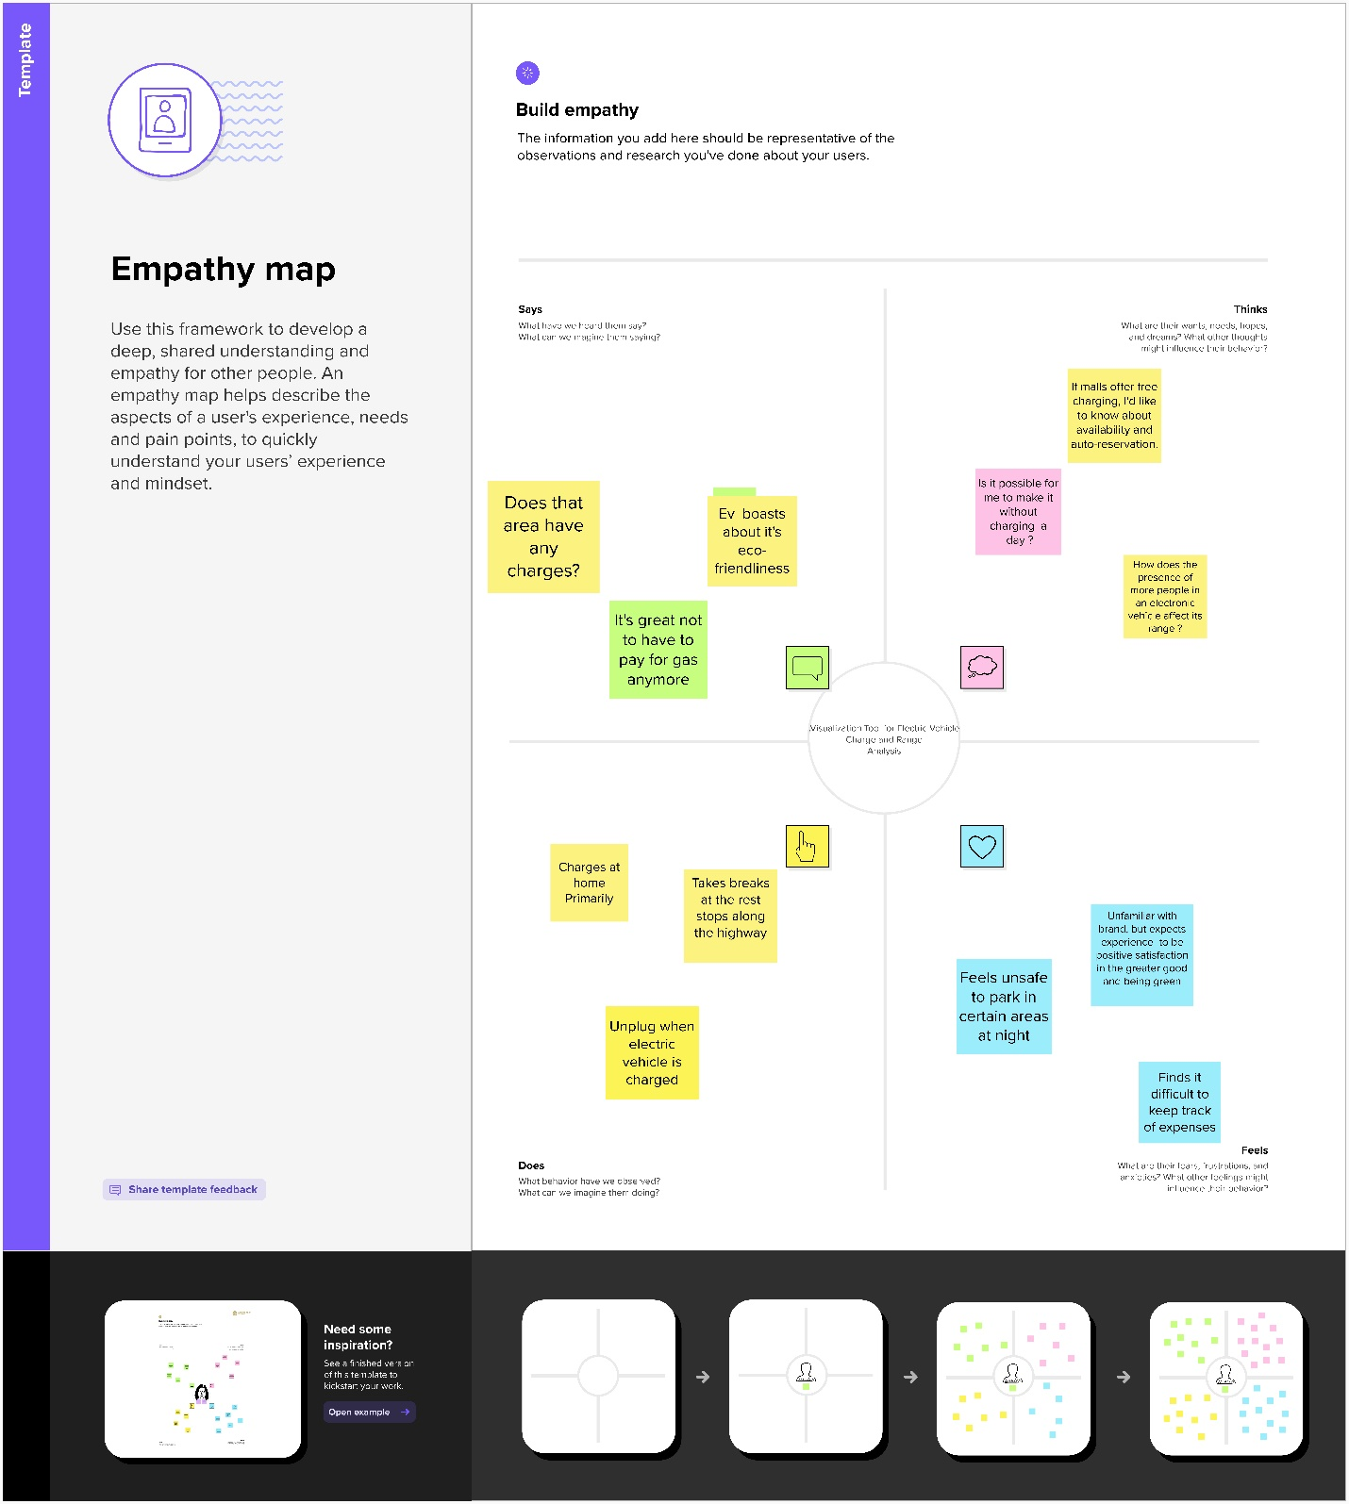

**Brainstorm:**

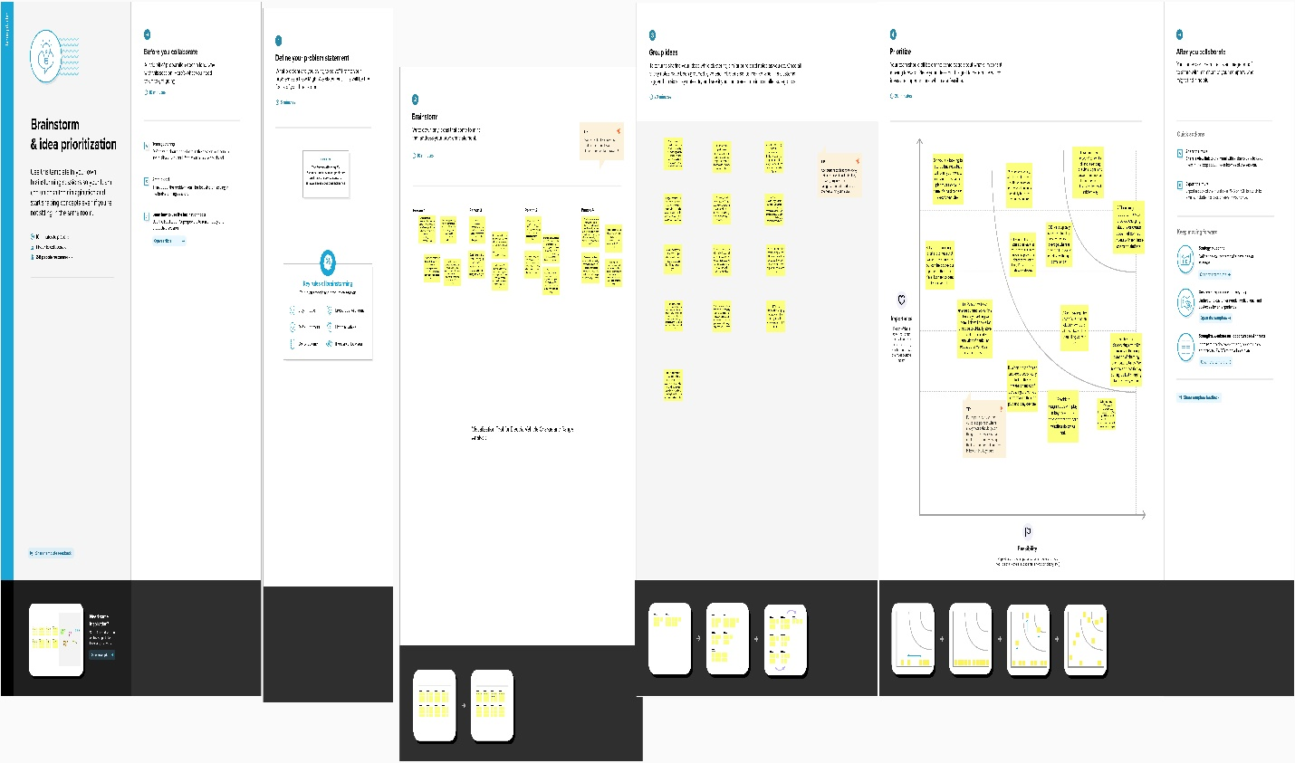

**Result:**

The results of an EV analysis are typically published in a report, which may include recommendations for improving vehicles performance in the future. These recommendations may be implemented by the relevant authorities or industry organizations.

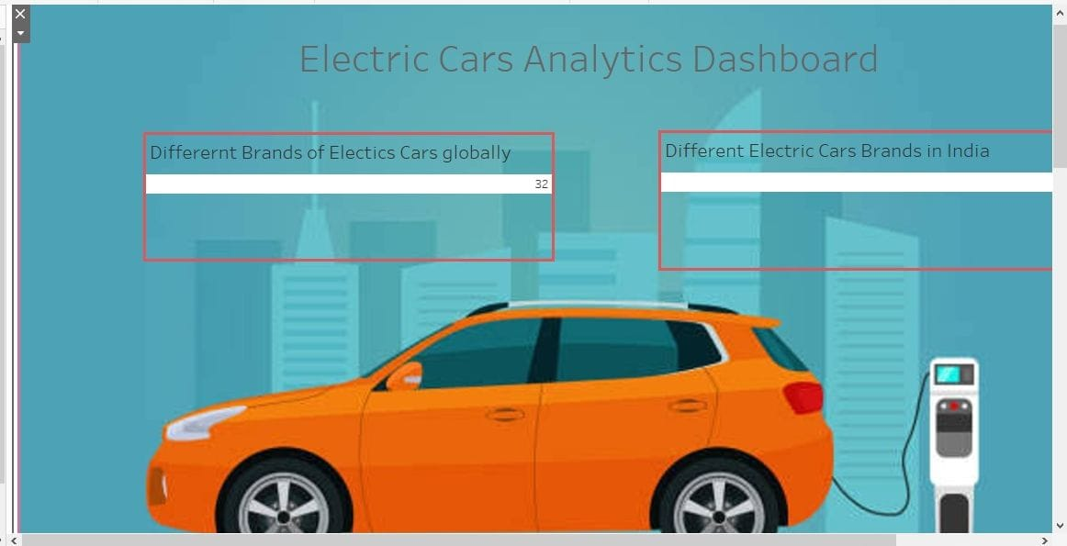

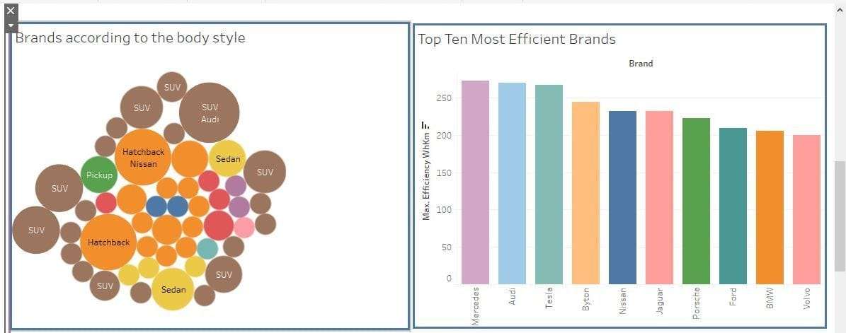

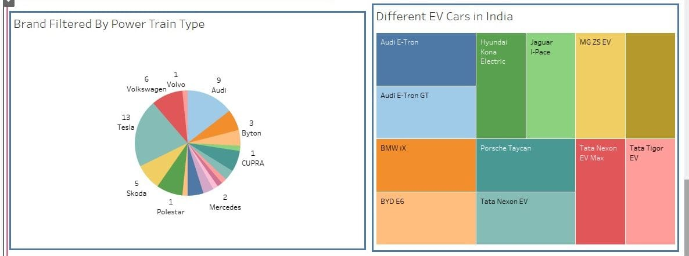

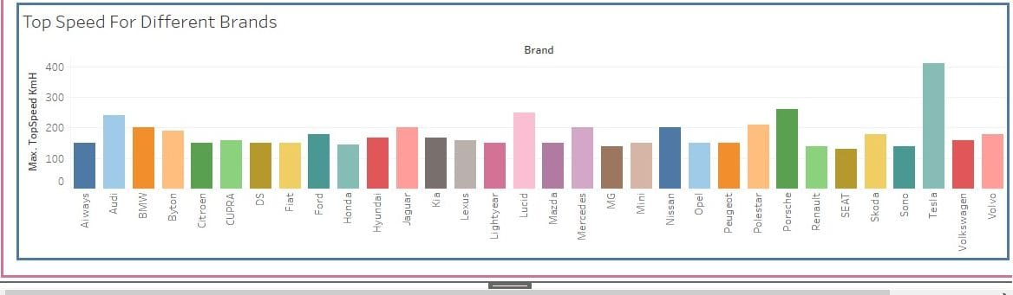

|  |  |
| --- | --- |
| **ADVANTAGES** | **DISADVANTAGES** |
| Performing an EV study with wide variety of data which are routinely collected from the dataset is effective . | Price of EV are more than than the gasoline vehicles and EV's are not reached to the people. |
| Comprehensive EV information including efficiency, power, speed , price,brands included in the data set , which gives the information about EV and gives the knowledge about EV. | EV Recharge stations are not available in many areas. |

**Applications:**

* Environmental protection.
* Economic Growth.
* Cost Savings.
* Reduced Pollution.

**CONCLUSION:**

The published dash board and relevent stories of the EV anlysis in the webpage helps to improve the electric vehicles in the future.

**FUTURE SCOPE:**

**There are no emissions:**

Electric automobiles are being developed primarily because they do not emit any pollution when driving. An electric vehicle is propelled by a battery-powered electric motor. There is no burning of fuel. An electric vehicle does not have an exhaust system. It's the best road transportation solution at a time when global CO2 emissions and air pollution must be drastically cut.

**Comfortable and quiet:**

Unlike a combustion engine, an electric motor produces very little noise. As a result, the silence inside an electric vehicle is unmistakable. Additionally, unlike a combustion engine, an electric motor does not produce any vibrations or resonance. The vibration-free and silent drivetrain adds to the relaxation.

**Requires less maintenance:**

Electric drivetrain technology is much simpler than that of a combustion engine. Because only a few sections need to be lubricated, it has far fewer (spinning) parts and fluids. So, as you may have guessed, an electric vehicle requires less maintenance.

**Access to city centres is unrestricted:**

Aside from the fact that more cities are implementing LEZs, these zones are also growing in size and strictness with time. With an electric car, you have limitless access to low-emission zones, now and in the future, wherever and whenever you want.

**Appendix:**

<file:///C:/Users/ELCOT/Documents/Arsha/Ev%20coding%203.html>

